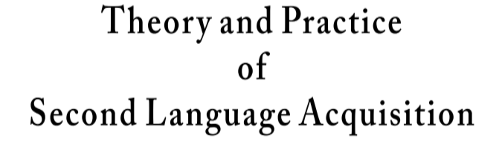


TAPSLA Author Declaration on the Use of Artificial Intelligence (AI) Tools
As part of its commitment to publication ethics and transparency, Theory and Practice of Second Language Acquisition (TAPSLA) requires authors to declare the use of artificial intelligence (AI)-assisted tools in the preparation of submitted manuscripts.
Please fill in the form and upload it along with your submission to the TAPSLA OJS system.
Manuscript title: _____________________________________________________________
Please select one of the following statements and, where applicable, provide the requested information:
☐ No AI tools were used in the preparation of this manuscript.
☐ AI-assisted tools were used, limited to language-related or technical support (e.g., grammar checking, stylistic editing, structural reorganization). If selected, please specify the tool(s) used and the nature of assistance provided (e.g., “language polishing,” “stylistic revision,” “structural editing,” “image generation”):
1)_________________________________________________________________________ 2)_________________________________________________________________________ 3)_________________________________________________________________________
The author(s) declare that:
•No AI tool has been listed as an author or co-author;
•All intellectual content, interpretations, arguments, and conclusions are the sole responsibility of the human author(s);
•The use of AI tools, where applicable, did not replace scholarly judgment or authorship.

Author’s Signature: ______________________________ Date: ______________________

